Review Book

**Table of Contents**

​ Introduction 2

​ Problem statement and their solutions 2

​ Core Problem:- 2

​ Solution:- 2

​ Domain Study:- 2

​ Identify the Stakeholder of the Product (Persona):- 2

​ Architecture Diagram 3

​ Architecture of ReviewBook 4

​ User Story or High-level Features 4

​ Prototype Screen 6

​ Spring boot Application - Microservice Architecture 7

​ Microservices Decomposition:- 7

​ API Gateway 8

​ Data models 8

​ Databases Implementation 10

​ RabbitMq of ReviewBook 10

​ Angular application Architecture 11

​ Screenshot of live pages 12

​ Landing Page Registration Page 12

​ registration as a normal user 13

​ Registration as a product owner 14

​ Home Page 15

​ footer 15

​ Product (add new product page) 16

​ My Products 17

​ Update Product 17

​ Profile update page 18

​ Review and Rating pages 19

​ review page 19

​ Technology Used 20

​ Conclusion 20

​ References 20

​ Source code:- 20

# Introduction

## Problem statement and their solutions

#### Core Problem:-

**How to motivate max. number of consumers to provide genuine reviews and ratings that can influence buying decisions of other consumers**

#### Solution:-

Developed a Product – “ReviewBook platform”

## Domain Study:-

eCommerce => Reviews and ratings

## Identify the Stakeholder of the Product (Persona):-

* Businesses
* employees
* Investor of eCommerce with review & rating domain
* Customers(Users) and Provider of Product
* Sales executive or Influencers
* Sponsors
* Suppliers and vendors

# Architecture Diagram

# Architecture of ReviewBook

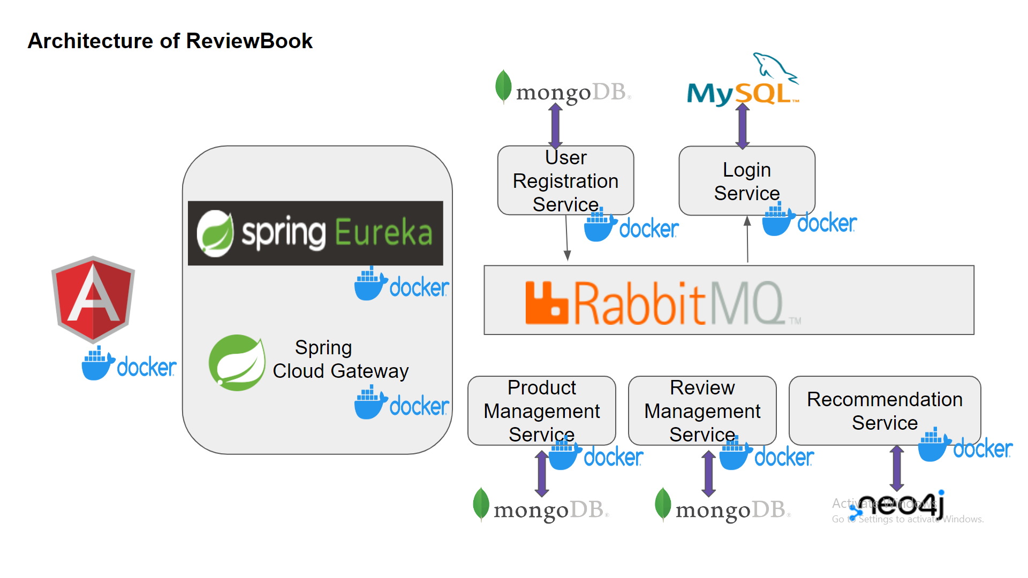

# User Story or **High-level** **Features**

* As a guest-user, I must be able see the landing page which displays basic information about the platform.
* As a guest-user, I must be able to See all the Available Products on the platform
* As a logged-in user, I must be able to read review and give review
* As a logged-in user, I must be able to like/rate other’s reviews.
* As a guest user, I must be able to register myself on the platform as a regular user or as a product owner.
* As a logged-in user, I must be able to search.
* As a registered user, I must be able to login using correct credentials.
* As a Product Owner, I must be able to Add new Product details on the platform.
* As a Product owner, I must be able to Update my added products.
* As a Product Owner, I must be able to Delete my existing Product on the platform.
* As a logged-in user, I must be able to view and edit my profile.
* As a Product Owner, I must be able to see the product that I have added so far on the platform

# Prototype Screen

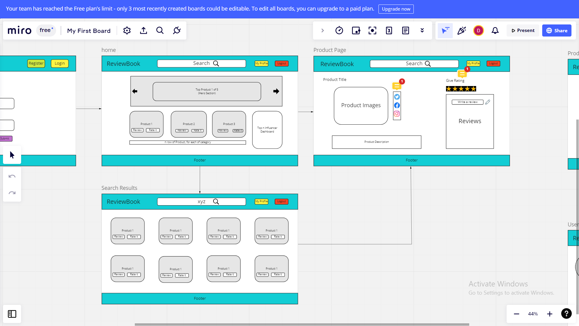

# 

# Spring boot Application - Microservice Architecture

## Microservices Decomposition:-

1. Login microservice
2. User Register and Organization Registration
3. Product Management (Catalog)
4. Review Management service
5. Rating service
6. Search
7. Product Recommendation Management
8. Add Favorite service
9. Admin-Portal

## API Gateway

## Data models

* User-Registration

{

“username”:

“password”:

“Email”:

Role:

Organisation-Registration

“username”:

“password”:

“Organisation name”:

“GST IN”:

“Location”:

“email”:

}

* Login

{

“username”:

“Password”:

“role”:”ProductOwner/user”

}

* Product

{

“productId”:UUID

“productName”:

“productDescription”:

“verificationId”:

“category”:

“averageRating”:

“imageByte”:Byte[]

“Specifications”:String[]

}

* Review

{

"reviewId":UUID,

"productId": UUID (will get it from address bar),

"productCategory":

"reviewTitle":"String",

"reviewText":"String",

"reviewedBy":"name"(will get it from localstorage),

"reviewDate":Date,

"likeCount":number,

"dislikeCount":number,

"likedUser":HashSet of username,

"dislikedUser": Hashset of username,

}

* Rating

{

“userId”:

“productId:

“productRating”,

“InfluencerSoreOrRating”

}

## Databases Implementation

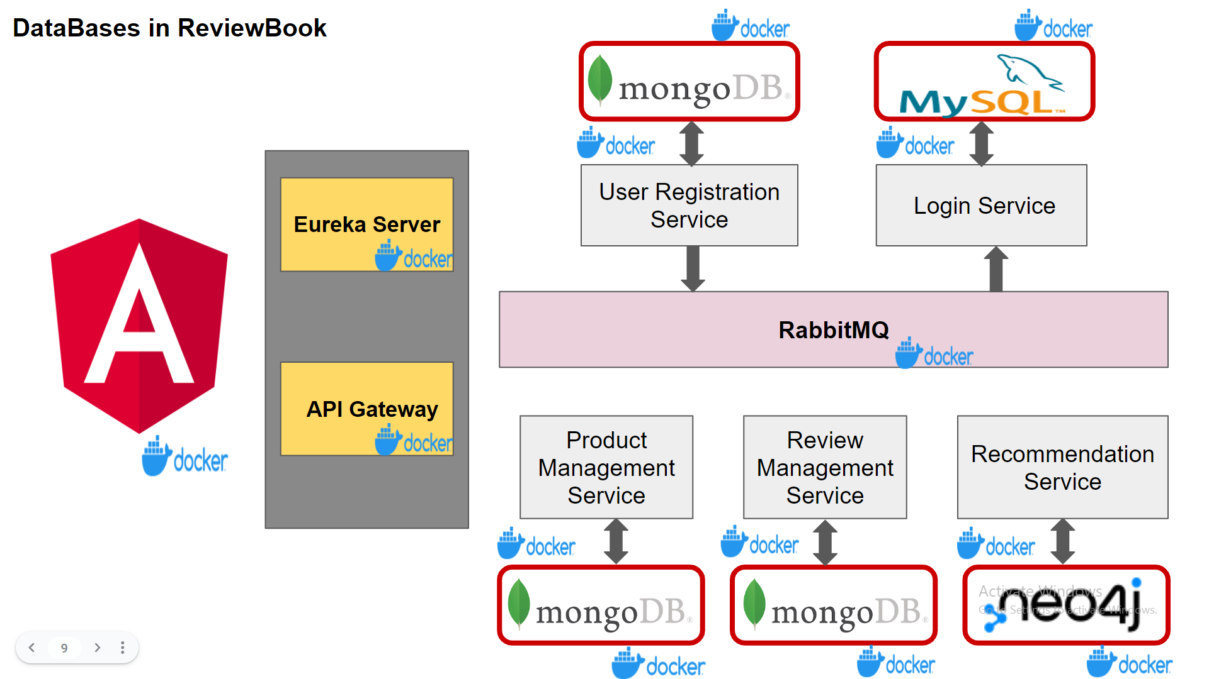

## RabbitMq of ReviewBook

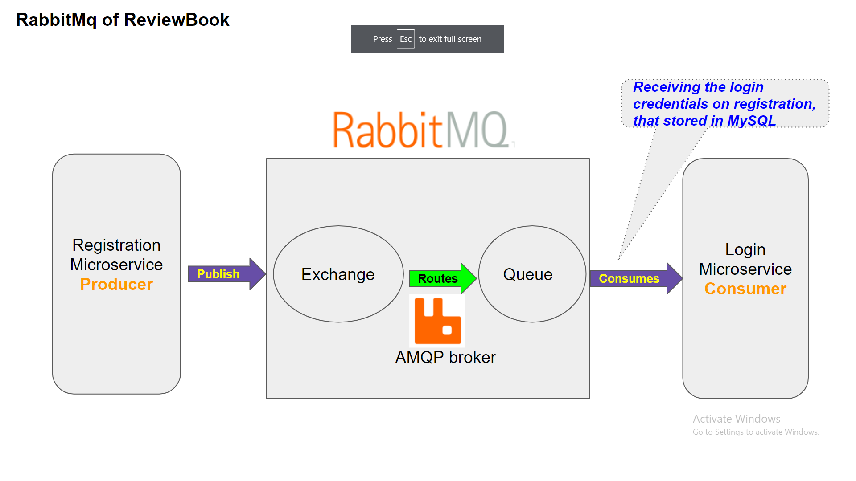

# Angular application Architecture

Product-features Module consists of UI functionality (components, services) implementation corresponding to each of microservices. Angular Materials, Bootstrap apart from angular is also used for designing the pages.   
  
A high-level of coding standard has been followed in angular code bases

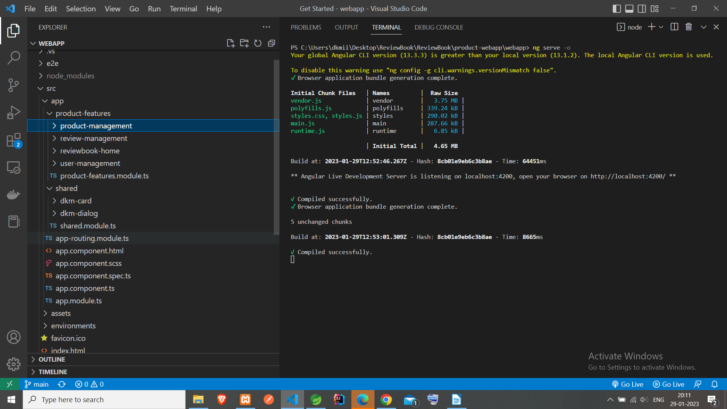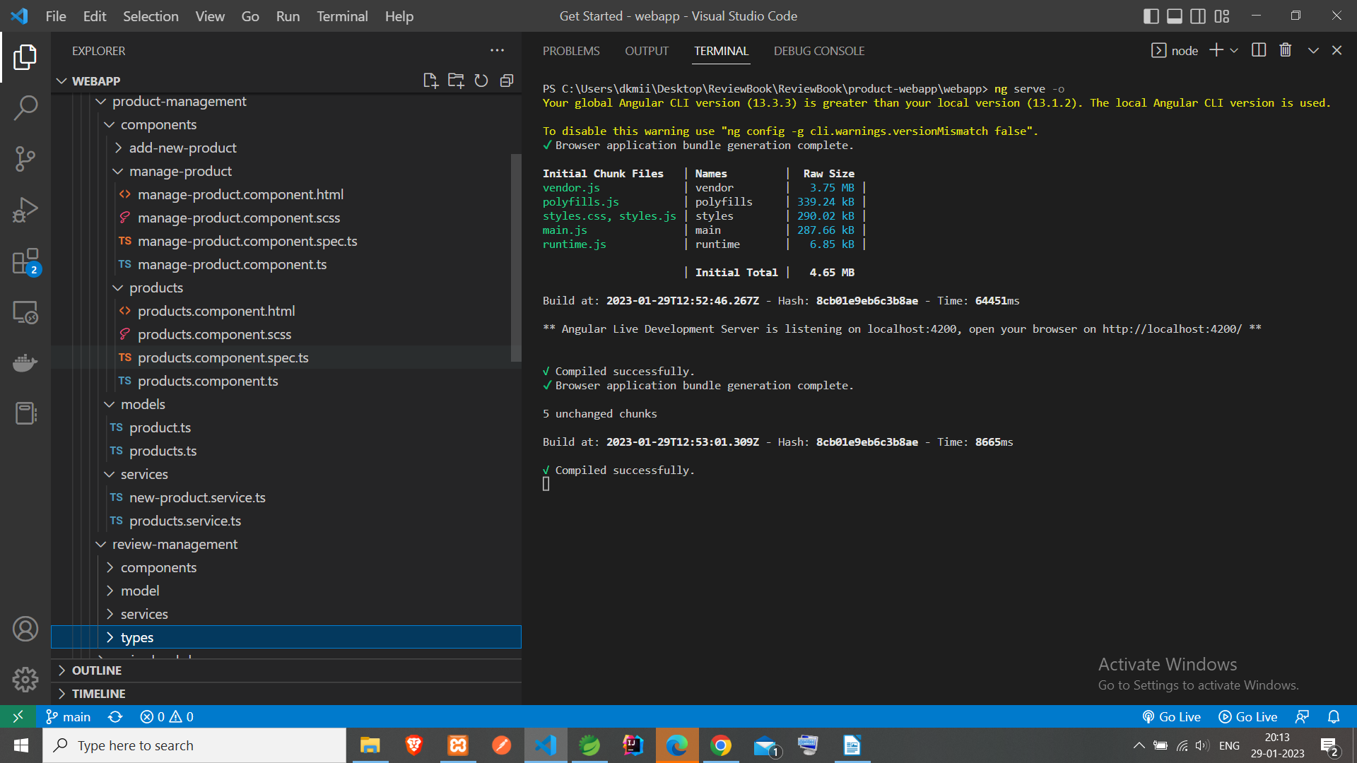

# Screenshot of live pages

#### Landing Page Registration Page

#### registration as a normal user

.

#### Registration as a product owner

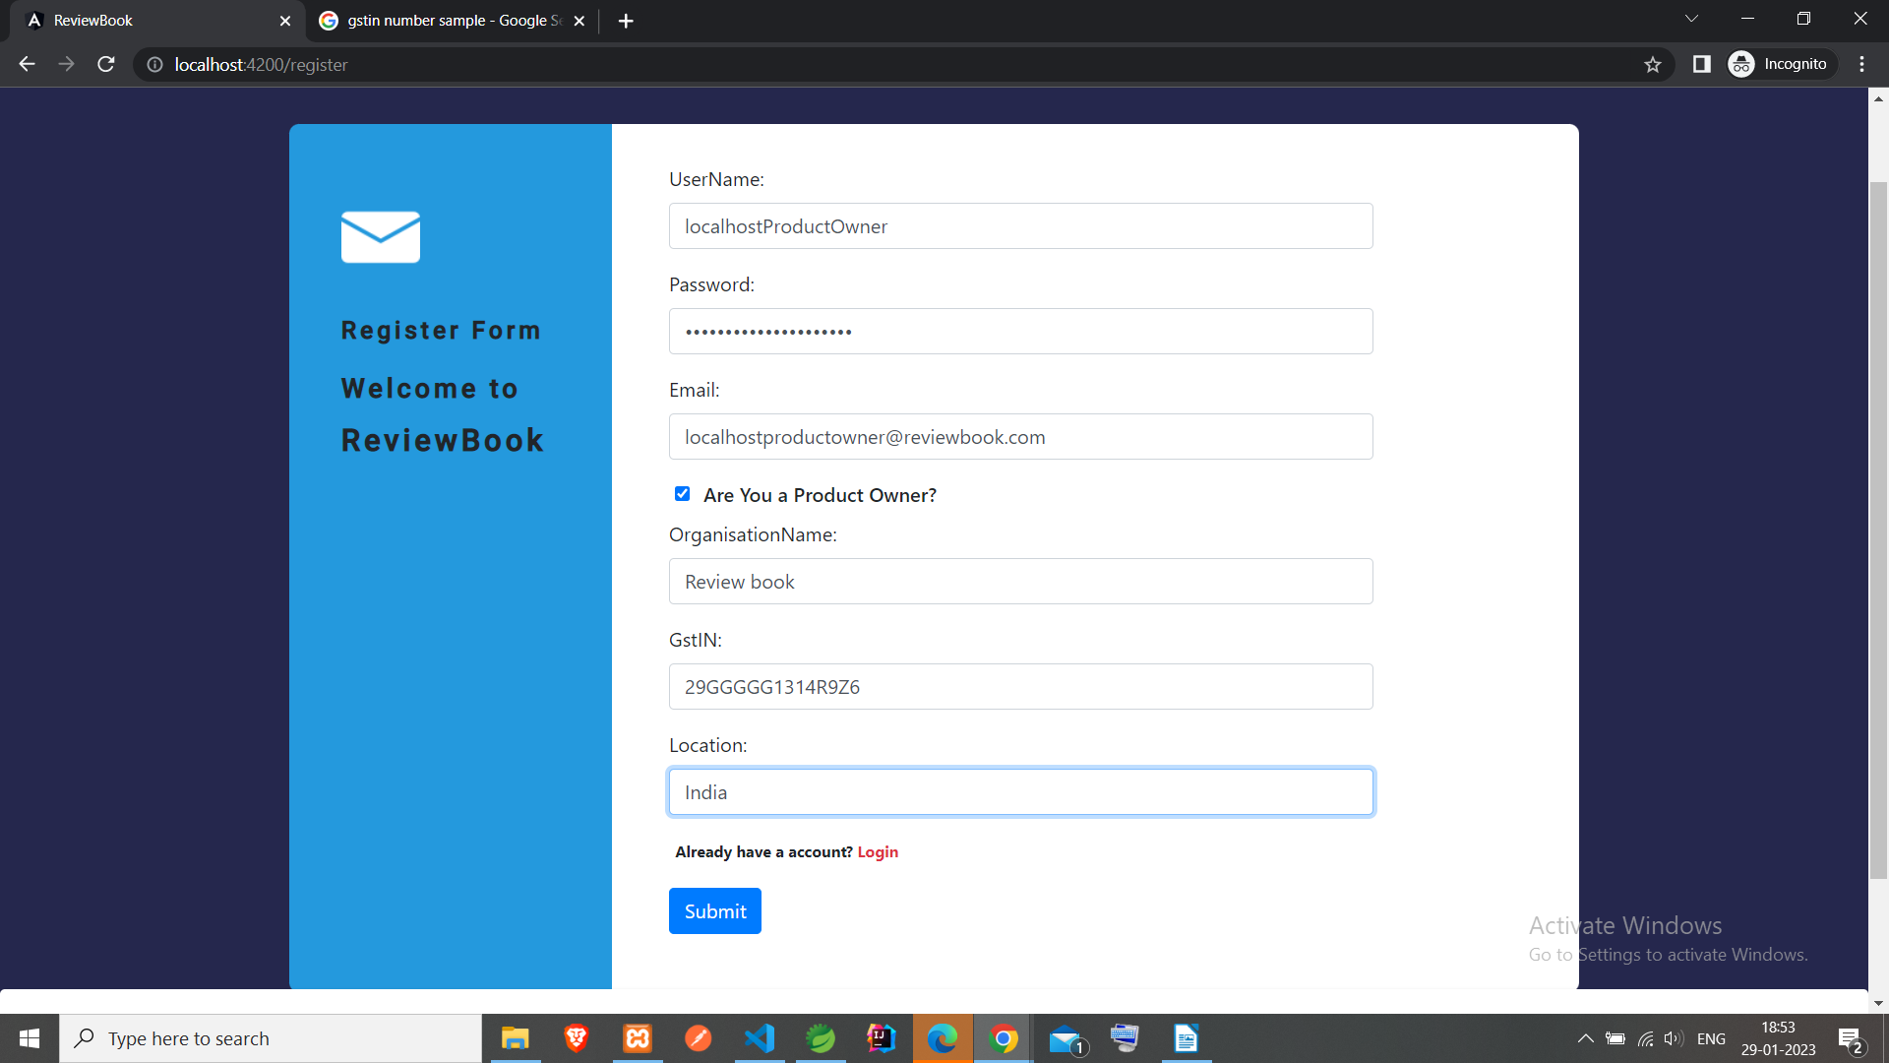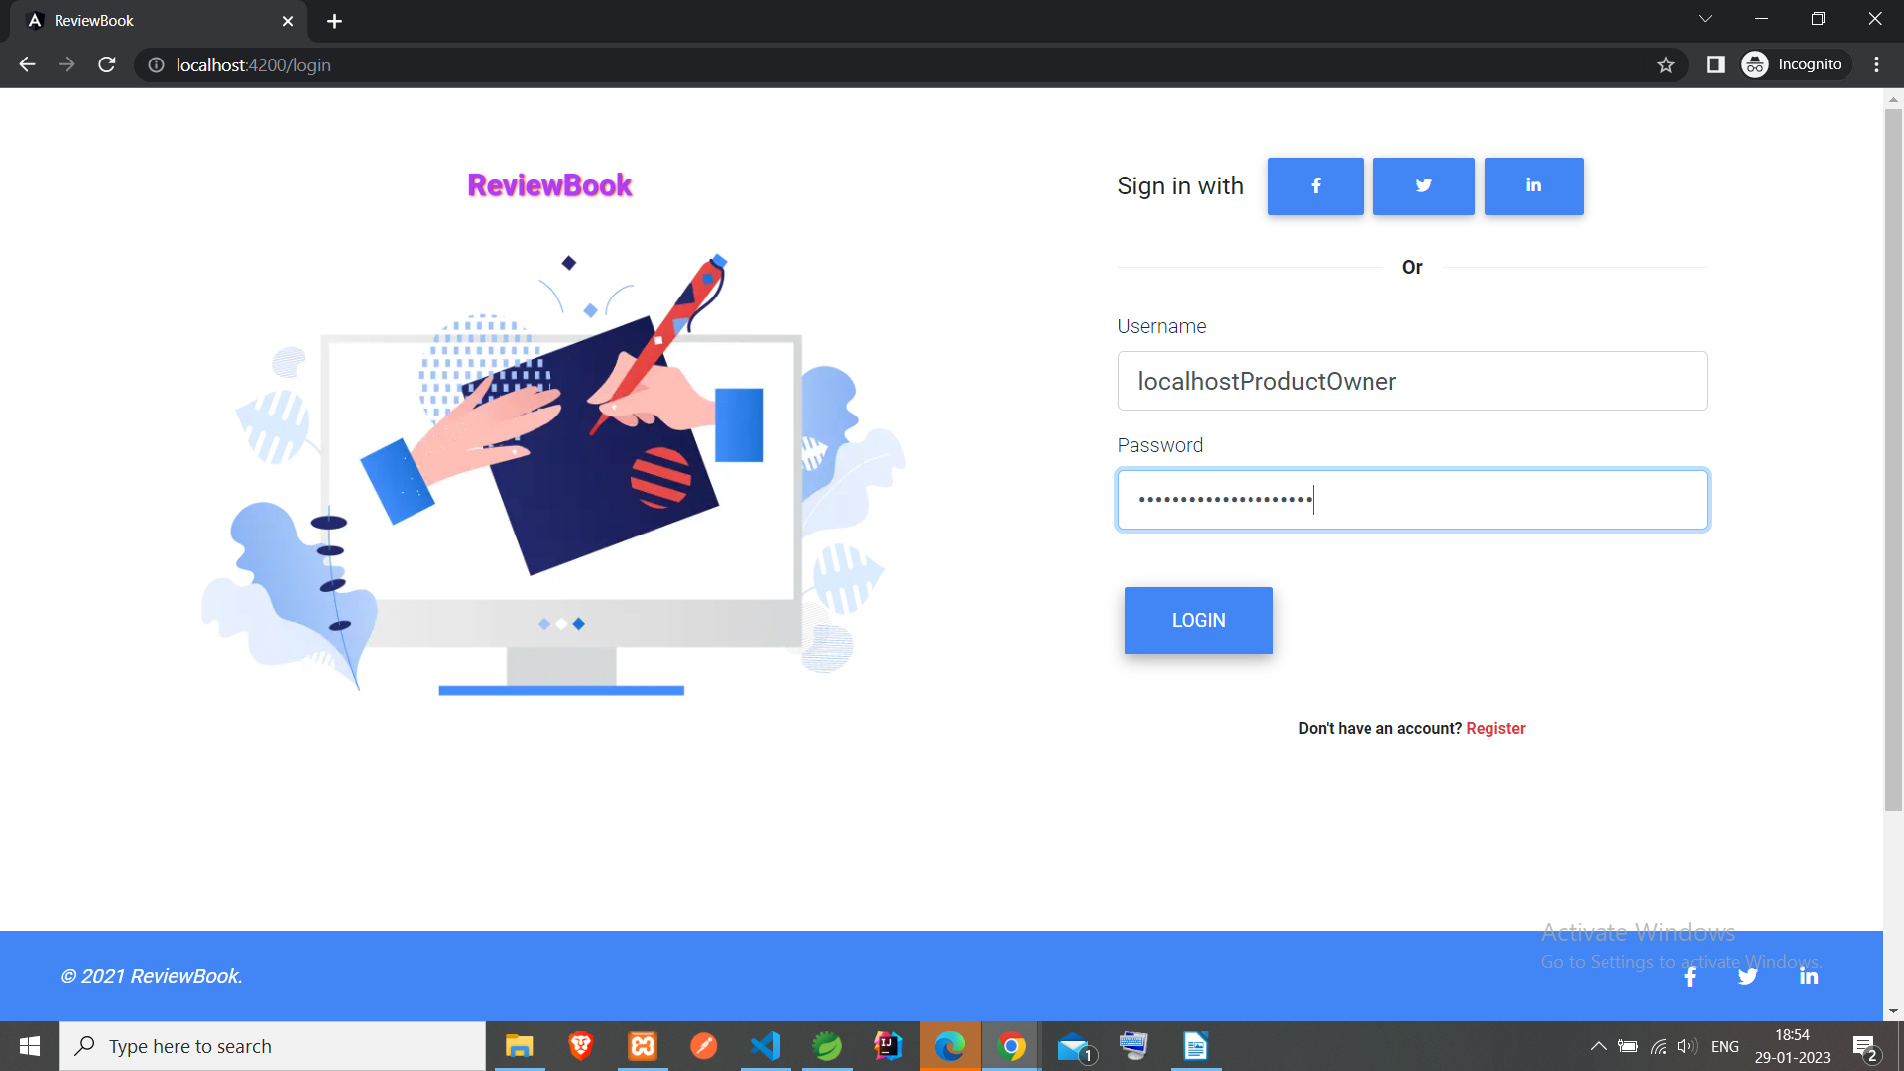Login page

#### Home Page

#### footer

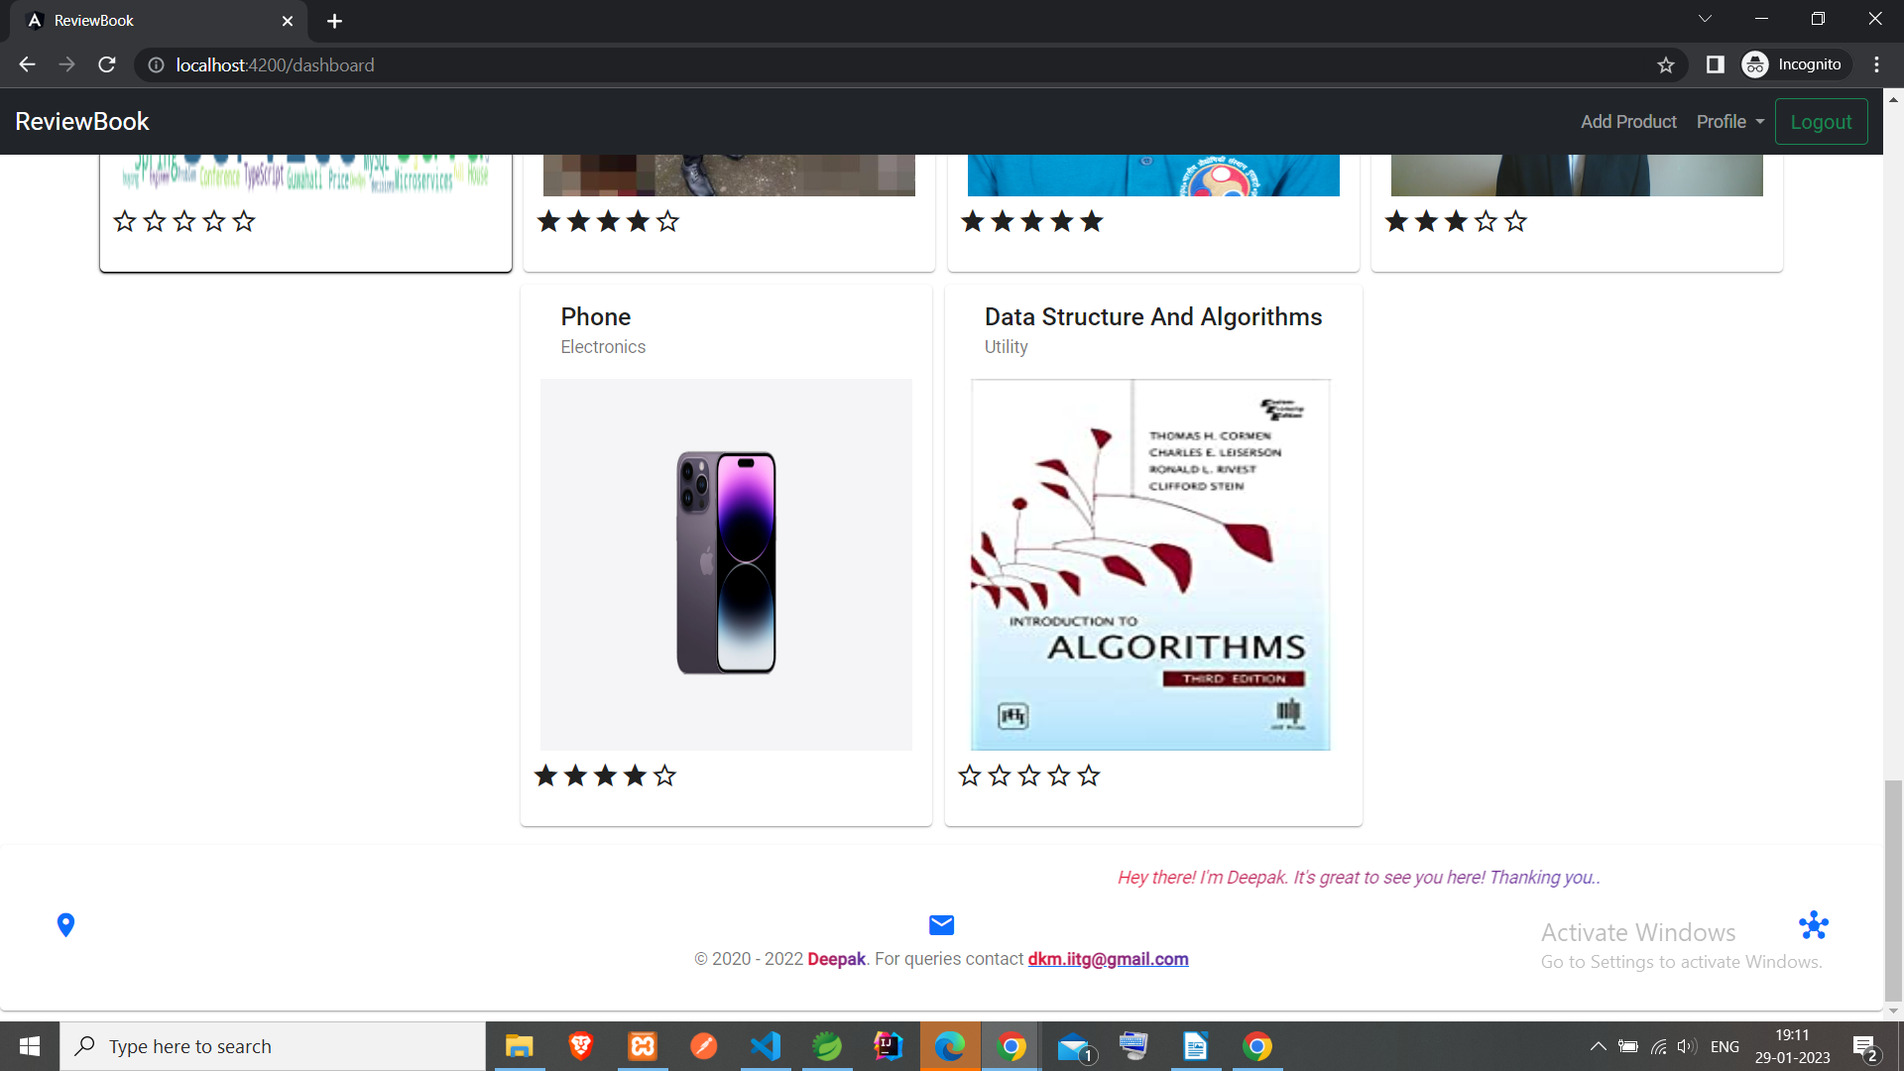

#### Product (add new product page)

#### My Products

#### Update Product

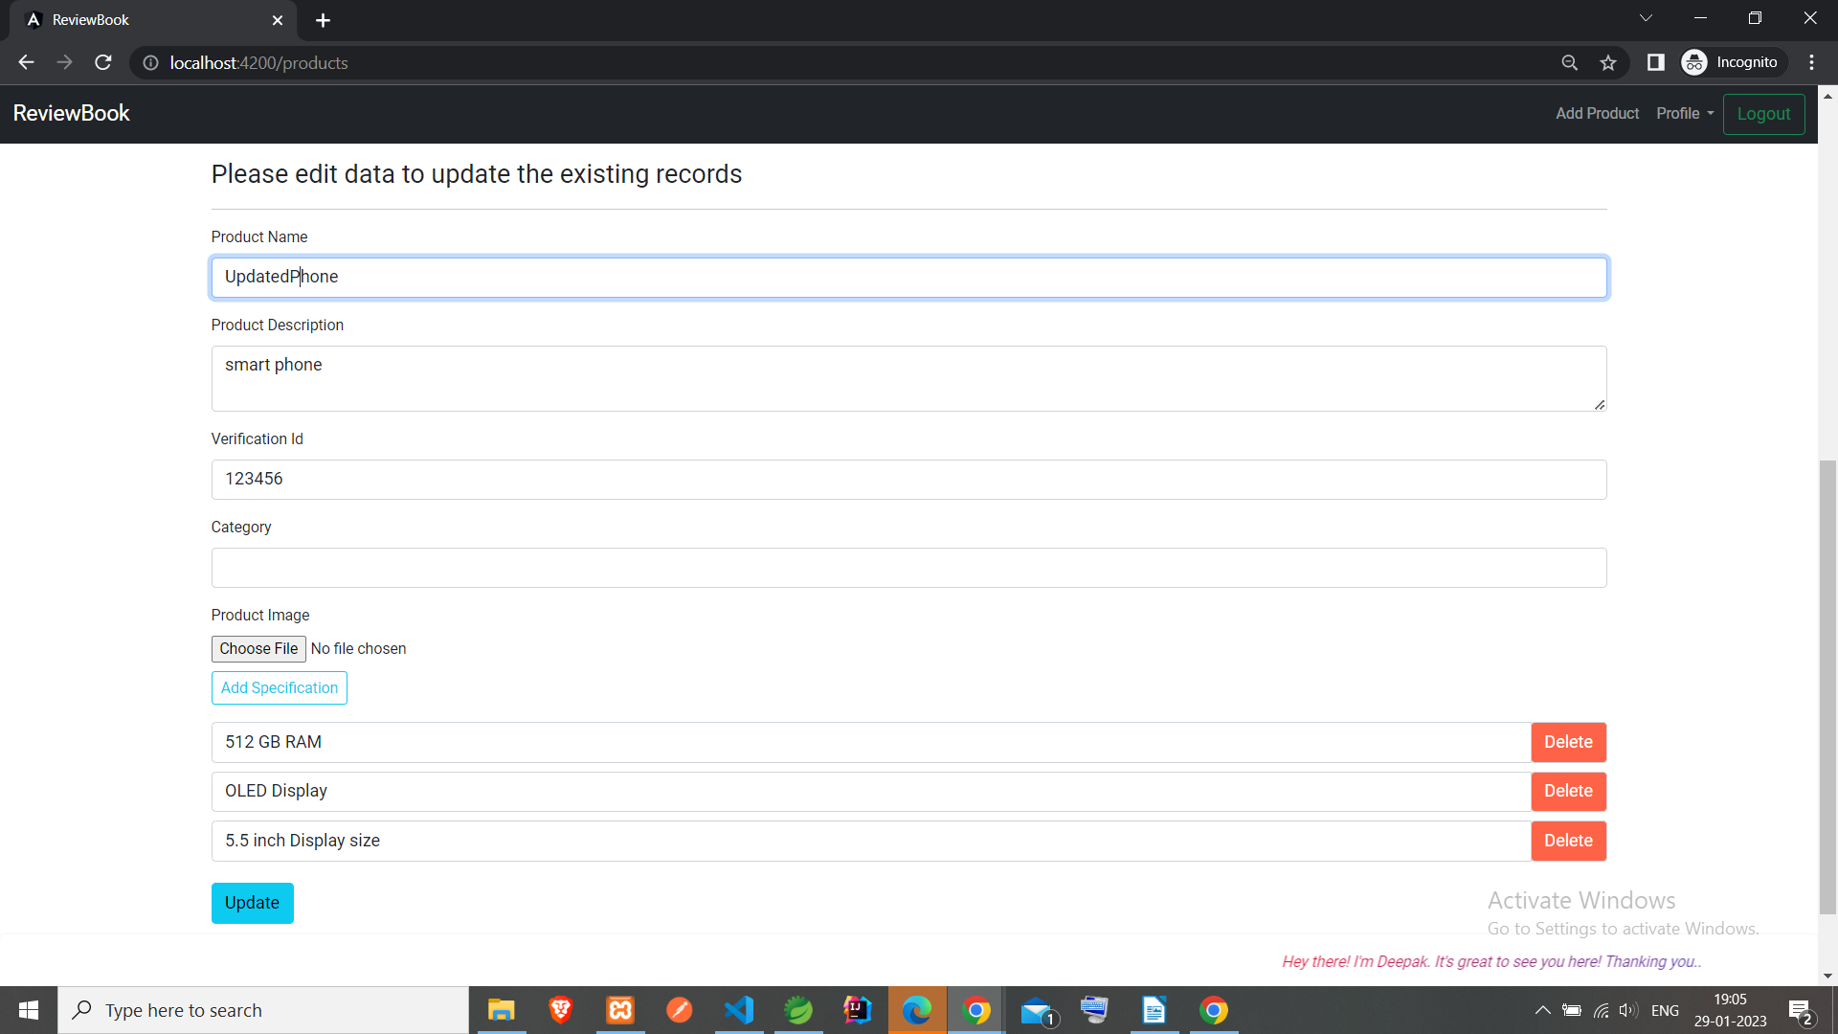

#### Profile update page

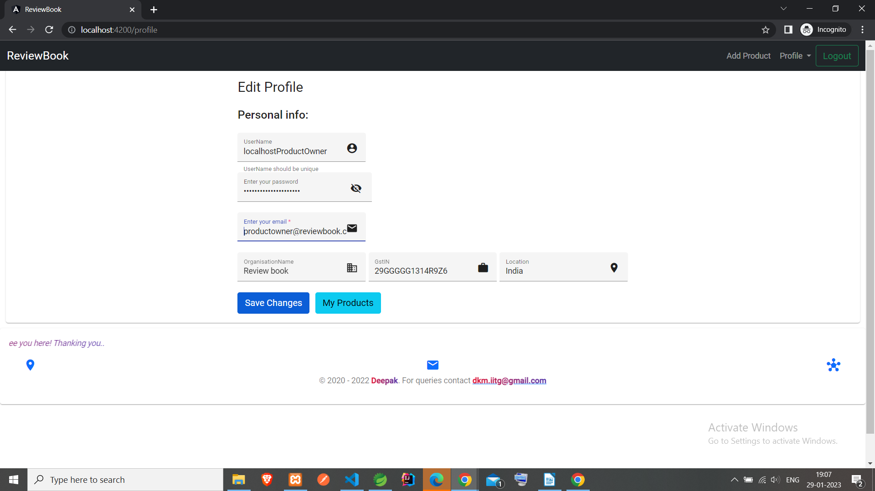

#### Review and Rating pages

#### review page

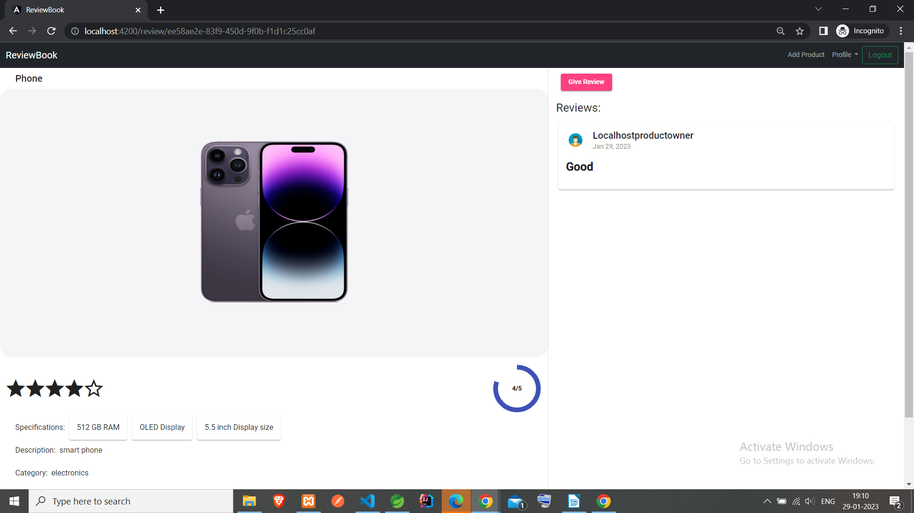

# Technology Used

# Conclusion

Developed a ReviewBook platform as solution the core problem, which is fully working as expected.

# References

#### Source code:-

https://github.com/deepak-mandal/ReviewBook

***END***